**IBM NAAN MUDHALVAN PROJECT**

**CLOUD APPLICATION DEVELOPMENT**

**PHASE-4 DEVELOPMENT PART-2**

Integrate the chatbot with facebook Messenger and Slack using respective API.

Ensure that the conversation flows naturally and that the chatbot responses are informative and accurate.

**1. Create a Watson Assistant instance:**

* If you don't already have a Watson Assistant instance, create one on the IBM Cloud platform.

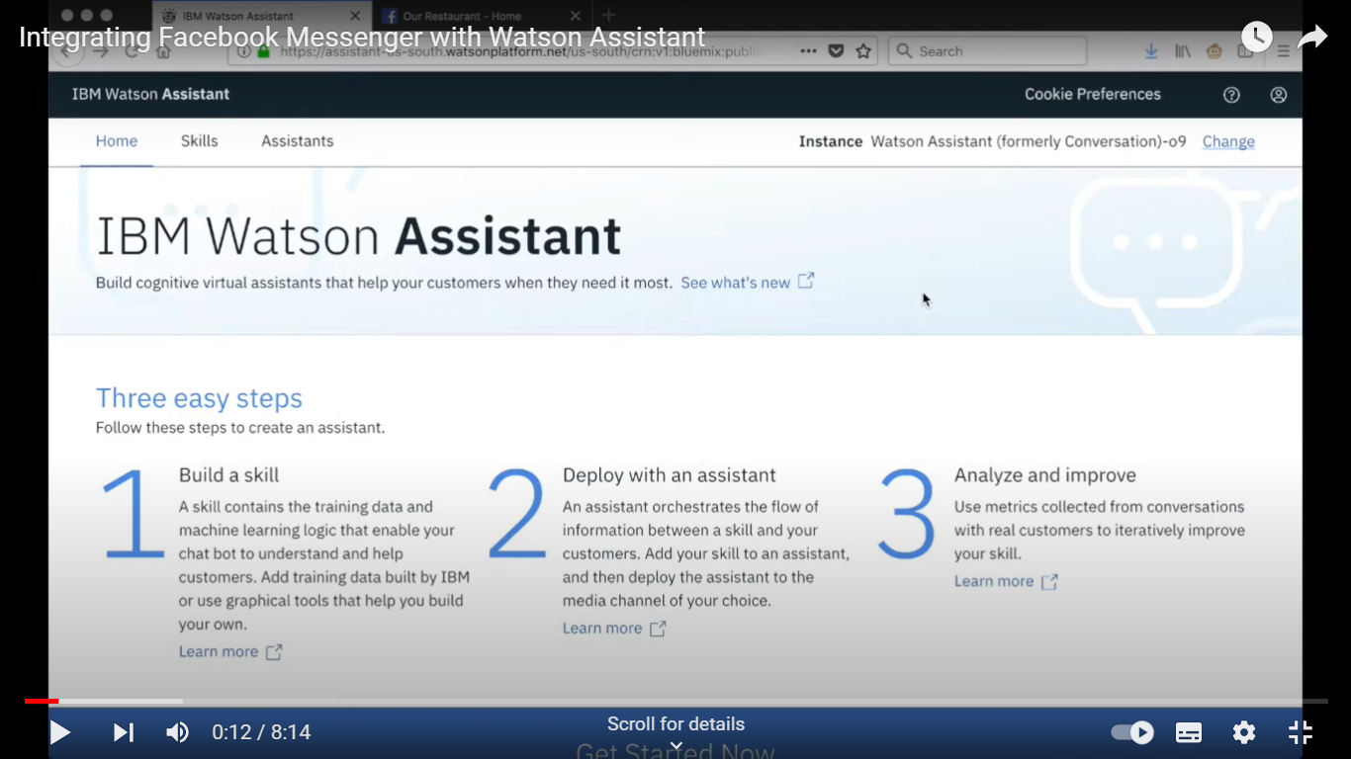

**2. Build and Train Your Chatbot:**

* Create and train your chatbot using the Watson Assistant interface. Define intents, entities, and dialog flows.

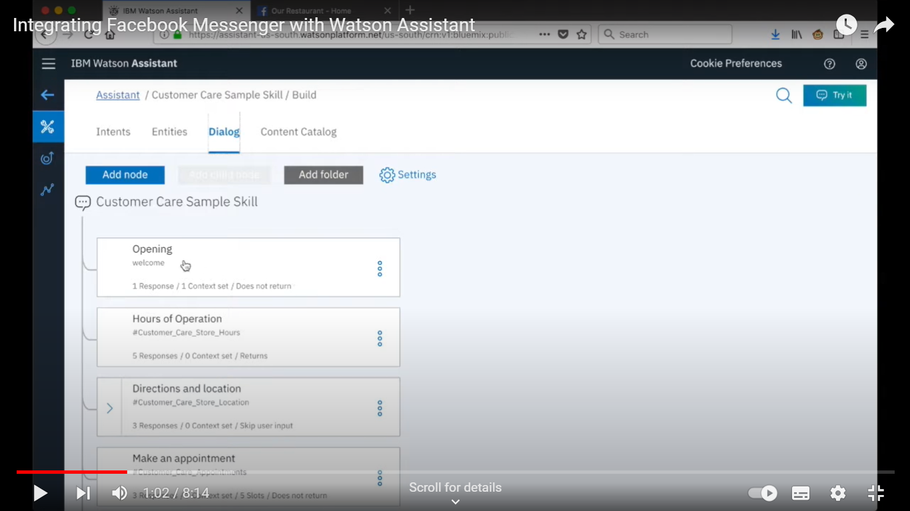

**3. Set Up Facebook Developer Account**:

* Go to the Facebook for Developers platform (https://developers.facebook.com/), create a new app, and set up a Facebook Page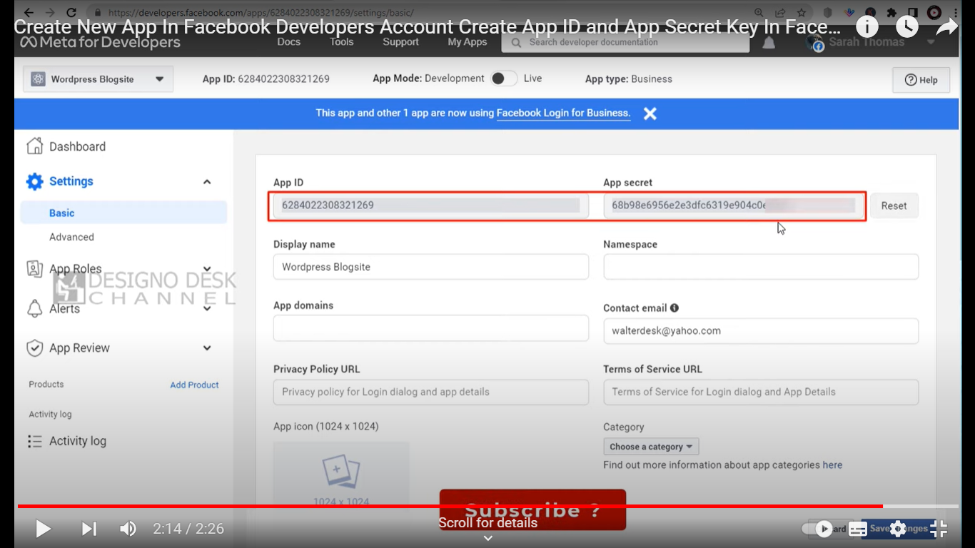

**4. Connect Watson Assistant with Facebook Messenger**

* In the Watson Assistant dashboard, navigate to the "Integrations" section.
* Select "Facebook Messenger" as an integration channel.
* Follow the instructions to link your Watson Assistant instance to your Facebook Page and generate a Facebook Page Access Token.

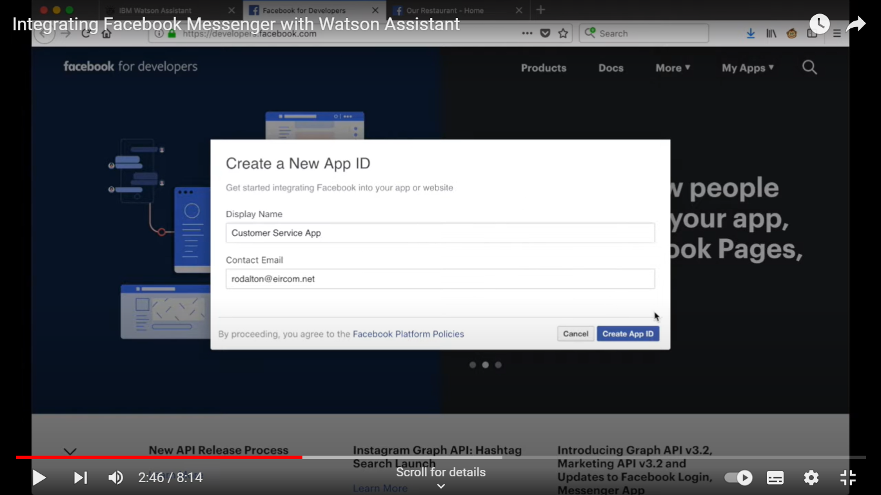

**5. Configure Webhooks:**

* Configure the webhook in your Facebook App settings to point to the URL provided by Watson Assistant.

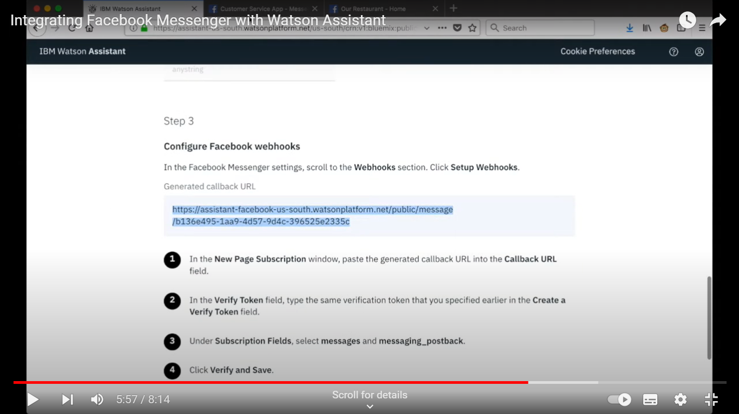

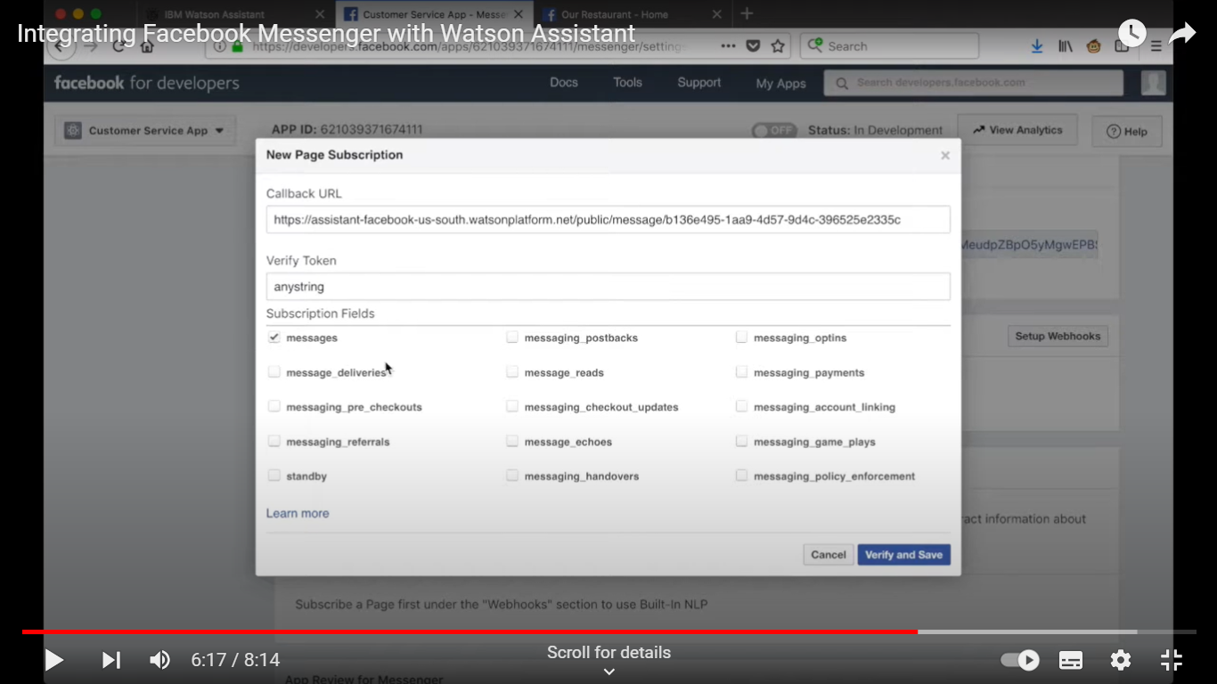

**6. Test and Deploy:**

* Test your chatbot on Facebook Messenger. Once you're satisfied with the performance, deploy it for public access. 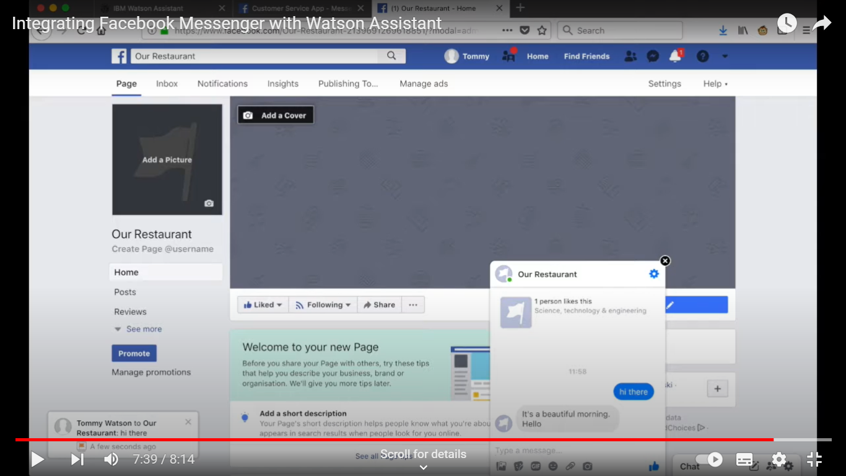

**Integrating Watson Assistant with Slack:**

**1. Create a Watson Assistant instance:**

* If you haven't already, create a Watson Assistant instance on the IBM Cloud platform.

**2. Develop Your Chatbot:**

* Create your chatbot in Watson Assistant, training it with the necessary intents, entities, and dialog.

**3. Create a Slack App:**

* Go to the Slack API portal (https://api.slack.com/apps) and create a new app for your chatbot

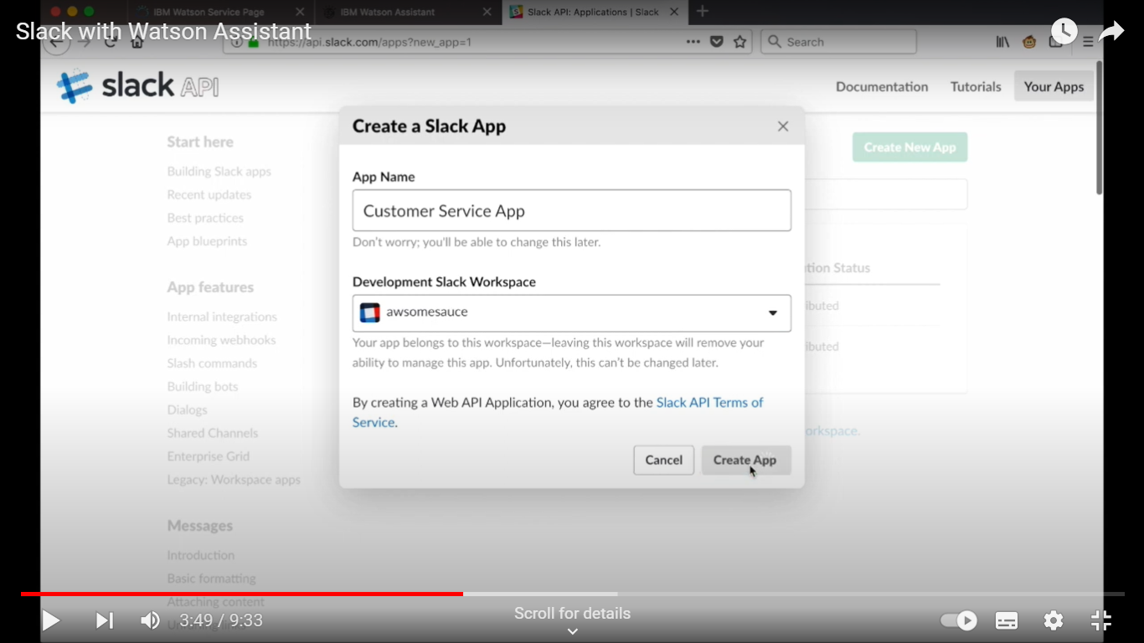

**4. Configure OAuth and Permissions:**

* In your Slack app's settings, configure OAuth scopes and permissions to allow your app to interact with Slack workspaces.

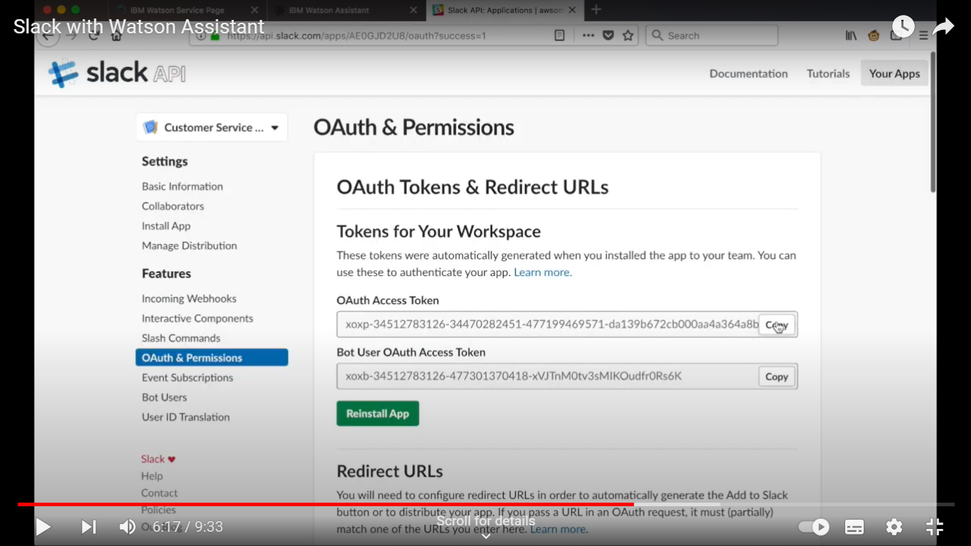

**5. Install Your App:**

* Install your app in the Slack workspace where you want to use the chatbot. This will generate an OAuth access token.

**6. Set Up Event Subscriptions:**

* Configure event subscriptions in your Slack app to listen for messages and other relevant events in the workspace.

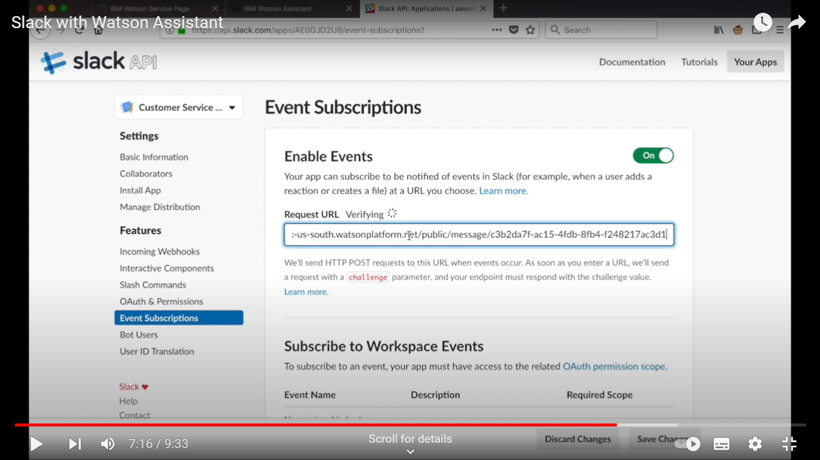

**7. Integrate with Watson Assistant:**

* Develop a middleware or server that connects your Slack app to Watson Assistant using the Watson Assistant API.

**8. Handle Events and Messages:**

* Handle incoming events and messages from Slack and send them to Watson Assistant. Process responses from Watson Assistant and send them back to Slack.

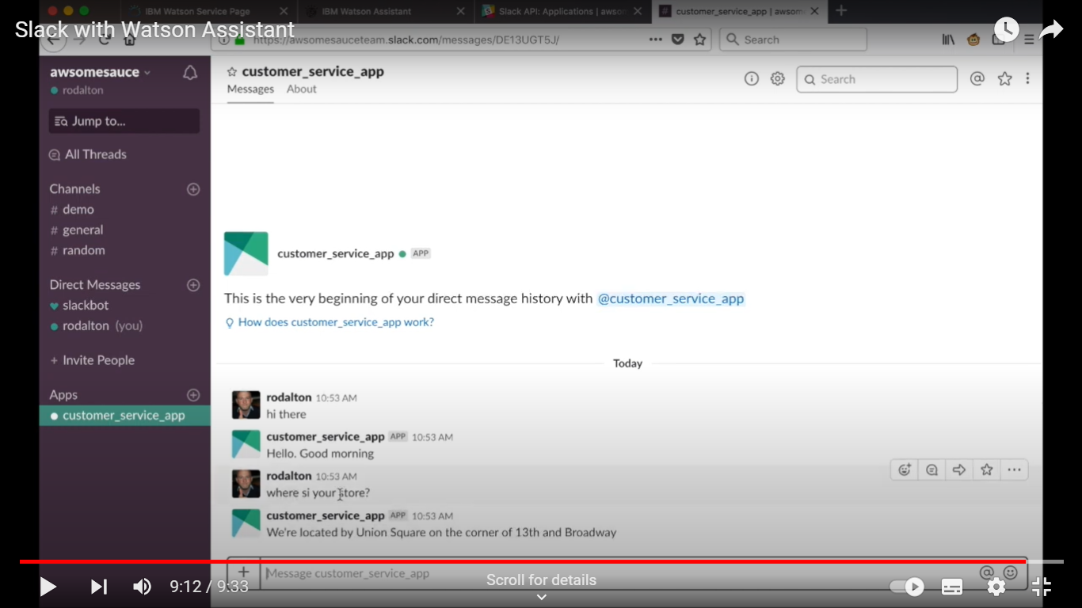

**9. Deploy Your Chatbot:**

* Host your middleware or server on a platform that's accessible from the internet.

**10. Test and Distribute:**

* Test your chatbot in the Slack workspace and distribute it to other users if desired.